**Preparing Liquid Honey for Fair Exhibit (the way I do it)**

**by: *Tang Johnston***

*What you will need:* **1 lb Glass Queenline Jar – Candy thermometer - Quart Jar - Cooking Pot – Fine Nylon**

for straining honey – **Spoon or Toothpick – Table Knife,** etc for skimming & Plenty of time, and patience.

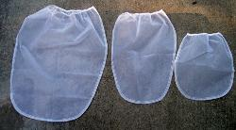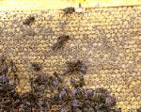

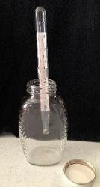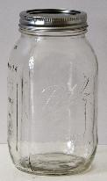

**Fully capped frame of honey. Use little or no smoke as honey absorbs odors**

**Nylon paint strainer - can be   
found at almost any hardware   
store, or where paint is sold.  
Wash strainer and dry   
thoroughly before using.  
These are the right size for   
filtering honey, although any fine   
nylon will work also.**

**One Quart Canning Jar**



**One lb Glass Queenline jar & Candy Thermometer**



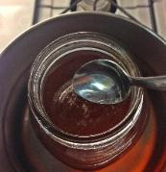

**#1  
You can use filtered   
melted crystalized   
honey, or liquid honey from fully capped frames. This gives you the lowest moisture   
content for your exhibit.  
  
I fill my quart jar about   
2/3 to 3/4 full, so as to   
have plenty for my  
one lb Queenline Jar  
  
Place jar with honey in   
a cooking pot with   
water, at least half way up the jar.  
  
Heat on medium heat   
until honey reaches   
130 to 140 degrees  
(using candy   
thermometer to   
measure temp)**

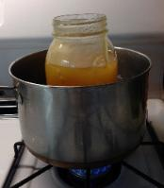

**#2  
Turn off heat and let   
the fine bubbles, wax   
and other particles   
float to the surface.  
  
No, I don't know how   
long...maybe 20-30 min.  
  
Then take a spoon and   
begin skimming off  
the flotation.  
  
You may need to reheat and skim several times to  
get it all (I think mine has mostly been three heatings and skimmings.)  
Some honey clears   
quickly, some is more   
cloudy and may not   
become completely   
clear. Enter it anyway!**

**I put a lid (no ring) on   
loosely.  Honey draws   
moisture from the air,   
so I do not want my   
honey to gain any   
moisture from the   
steam from the water.**

**#3  
When you are satisfied the honey is as clear and as particle free as you can get it, hold it   
up to a light and  
inspect your honey**

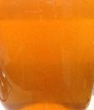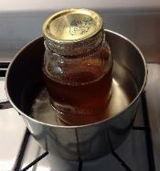

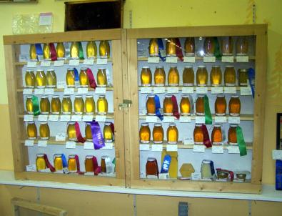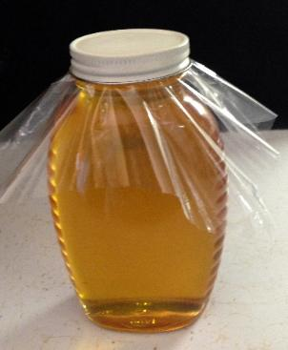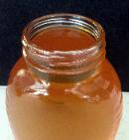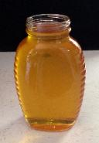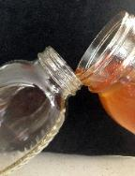

**There are many other exhibit options for  
Honey and Beekeeping**

**Check the State Fair Exhibitor Guide**

**Remember, you are never too "new at   
beekeeping"!  It's not even all about   
winning a ribbon!  People from all over the   
world come to the fair and examine and   
enjoy our entries. It makes a beekeeper   
and his family so proud to see their honey   
displayed in SABA's display case at the fair!**

**#6  
Ok!  Almost done!  Now I take a piece of thin   
plastic and lay it over the top of the jar and screw on the lid.  Wipe the jar free of fingerprints, etc and head for the fairgrounds to enter! (the plastic wrap will be removed before judging, it's just there to keep honey from getting on the underside of the lid and possibly disqualifying)  
  
Bragging rights!...customers love to hear what   
ribbons you have won with your honey**

**#5  
Yes, I see a bubble in   
there!  Here is where I   
get the toothpick or   
flat kitchen knife and   
carefully remove  
the bubble.    
Very carefully, as not to   
drizzle in the honey   
and create more   
bubbles.**

**#4  
When it is completely   
clarified you are ready   
to pour into the   
Queenline Jar.  
(It pours best when   
very warm)  
  
Very very slowly and   
gently pour the honey   
from the quart jar into   
the Queenline   
jar...along the side  
(like you would pour a   
bubbly drink)  
Continue to pour until   
the 1 lb jar is filled to   
within 1/4 inch from top**